**Installing Kafka and Zookeeper**

<https://kafka.apache.org/quickstart>

Point the data Dir to a valid Dir in windows

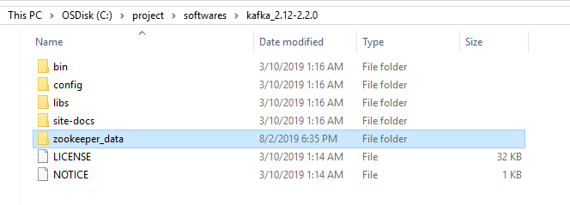

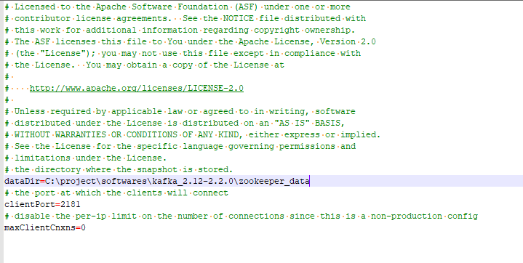

Create directory for Kafka logs

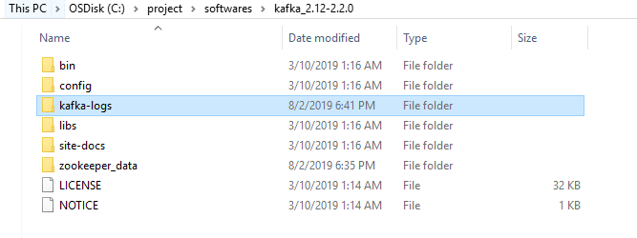

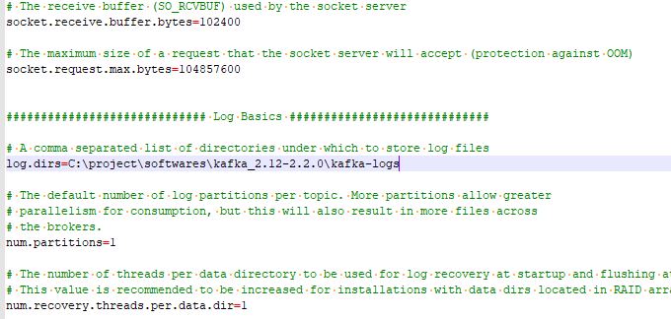

Change the log.dirs to valid directory in server.properties file

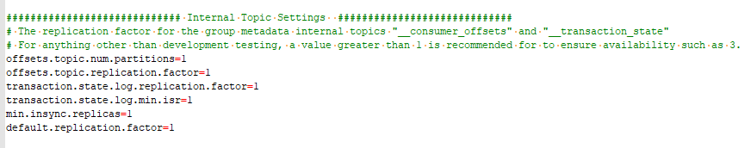

**Start Zookeeper**

C:\project\softwares\kafka_2.12-2.2.0\bin\windows>zookeeper-server-start.bat C:\project\softwares\kafka_2.12-2.2.0\config\zookeeper.properties

**Start Kafka**

C:\project\softwares\kafka_2.12-2.2.0\bin\windows>kafka-server-start.bat C:\project\softwares\kafka_2.12-2.2.0\config\server.properties

**To Test**

C:\project\softwares\kafka_2.12-2.2.0\bin\windows>zookeeper-shell.bat localhost:2181 ls /brokers/ids

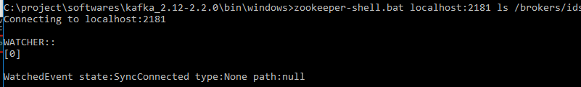

C:\project\softwares\kafka_2.12-2.2.0\bin\windows>kafka-topics.bat --create --zookeeper localhost:2181 --replication-factor 1 --partitions 1 --topic test

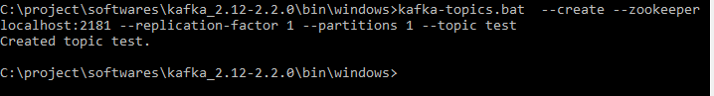

**Sending message to the topic test**

C:\project\softwares\kafka_2.12-2.2.0\bin\windows>kafka-console-producer.bat --broker-list localhost:9092 --topic test

>hello kafka

>how are you?



**Receiving message from topic test**

C:\project\softwares\kafka_2.12-2.2.0\bin\windows>kafka-console-consumer.bat --bootstrap-server localhost:9092 --topic test --from-beginning



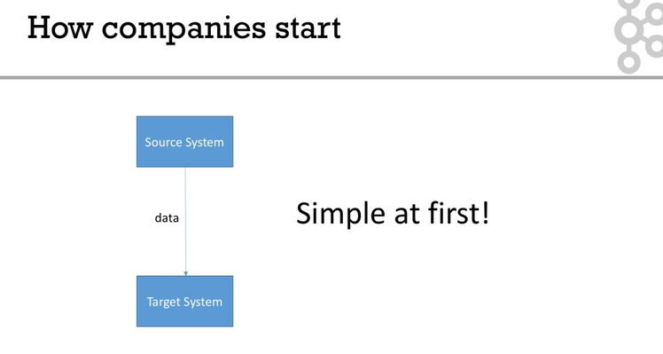

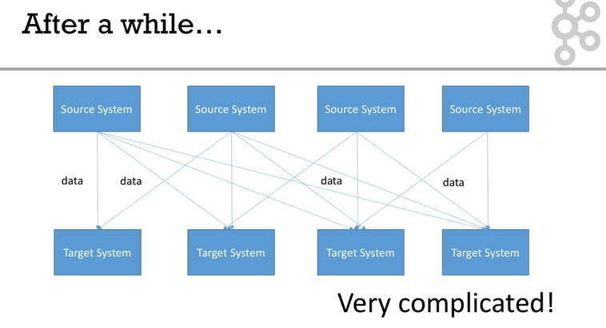

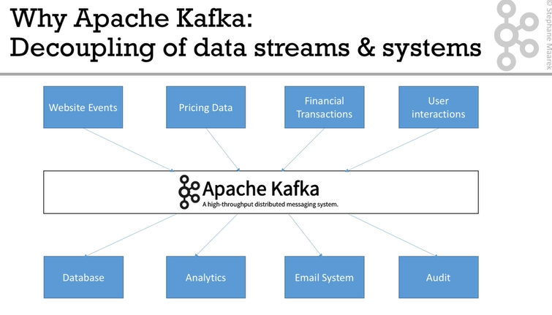

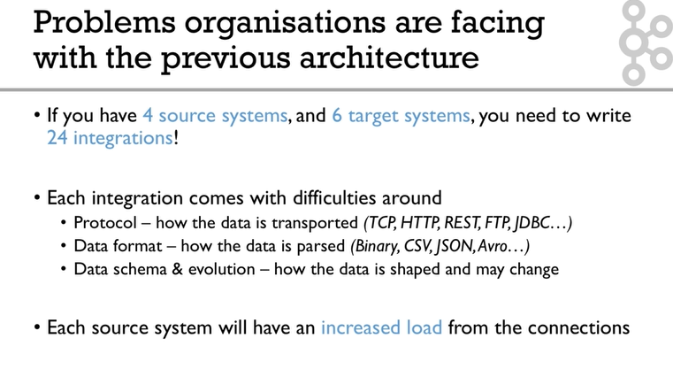

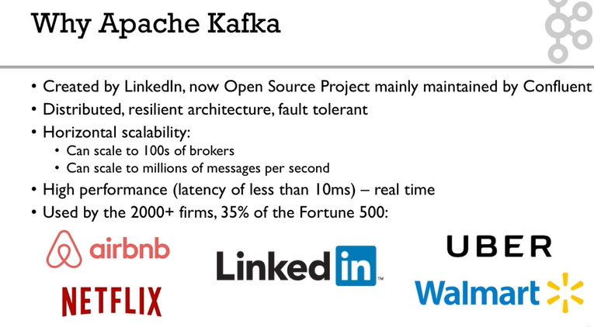

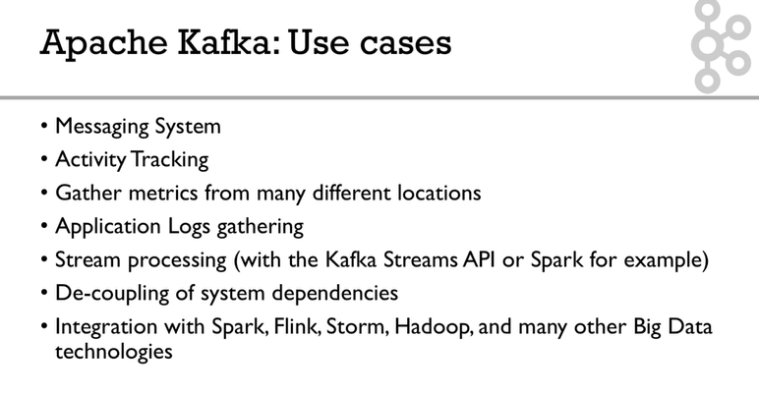

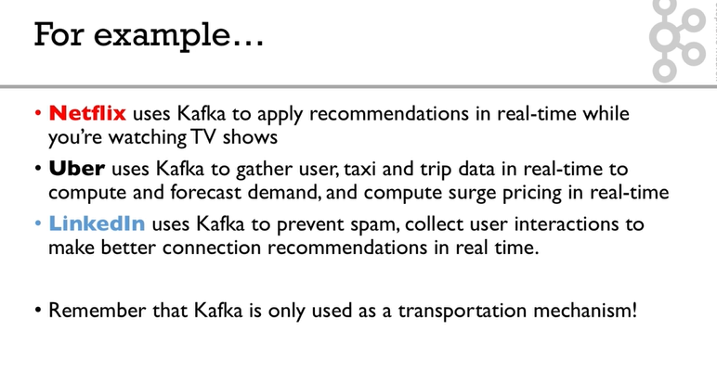

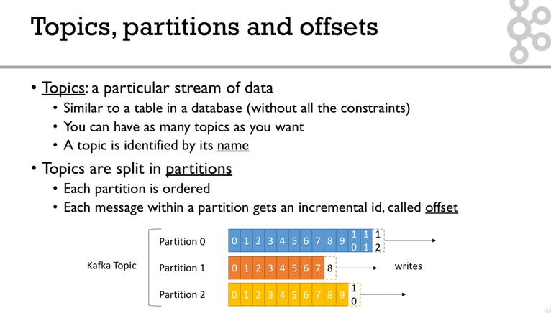

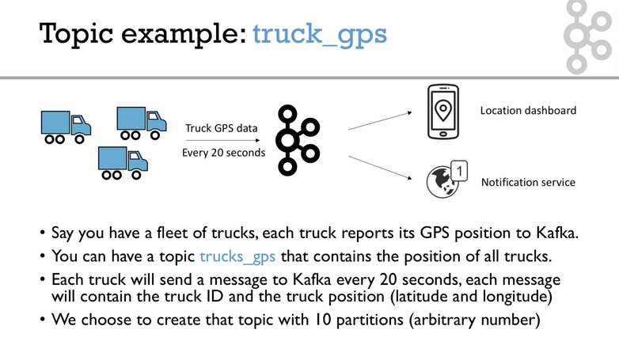

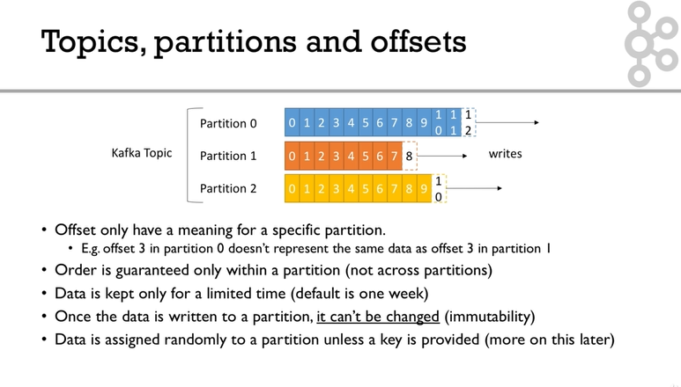

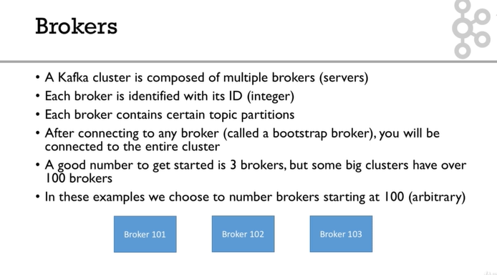

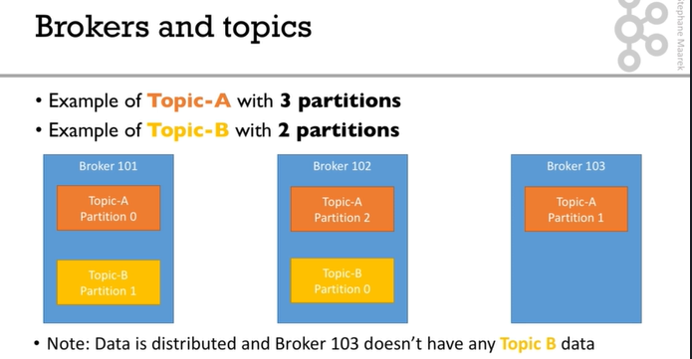

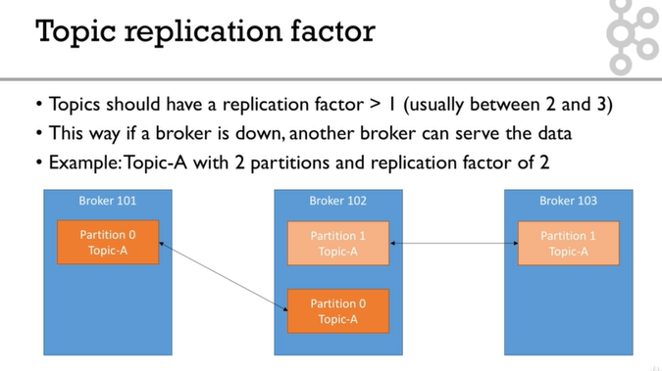

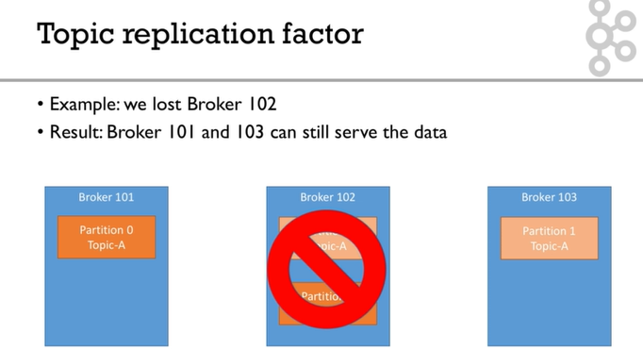

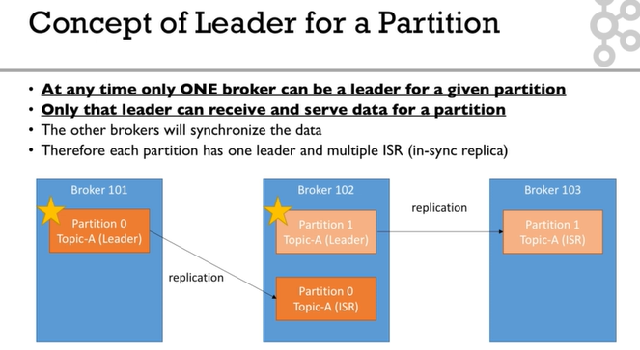

The leader and ISR are decided by zookeeper.

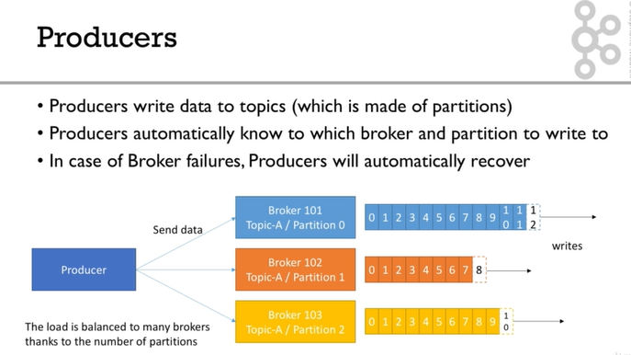

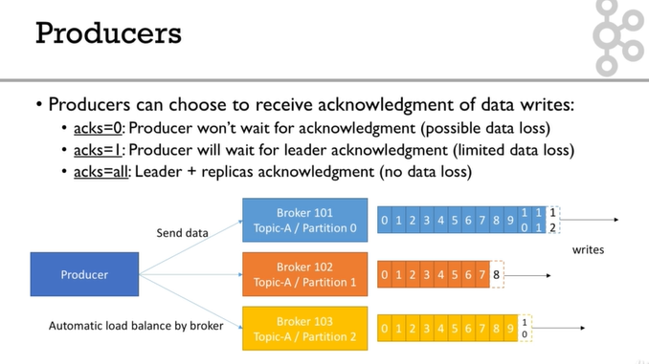

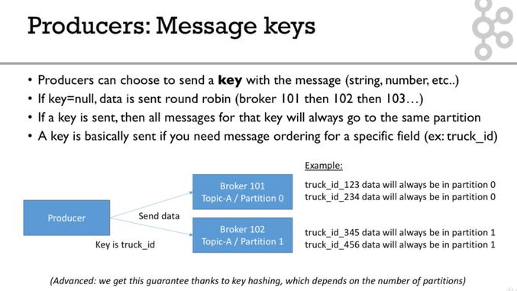

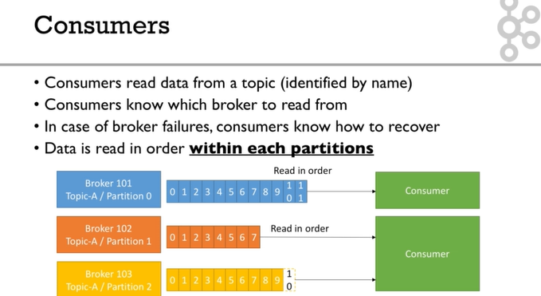

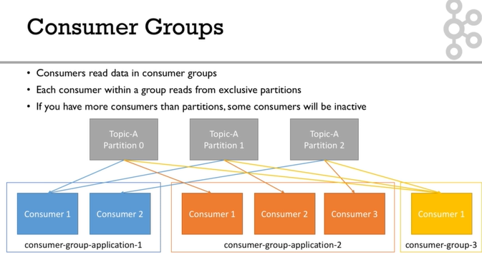

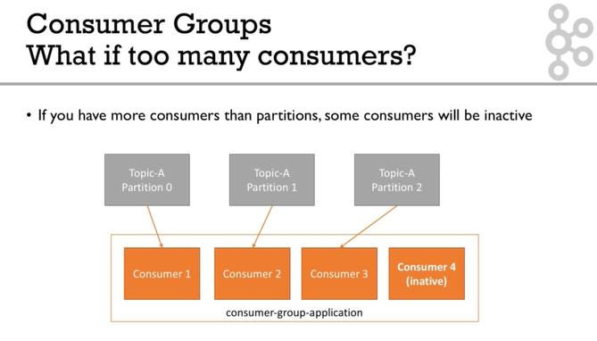

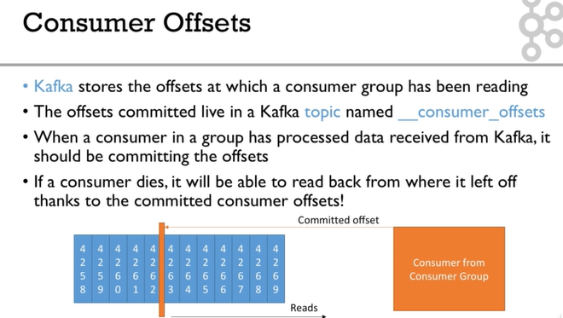

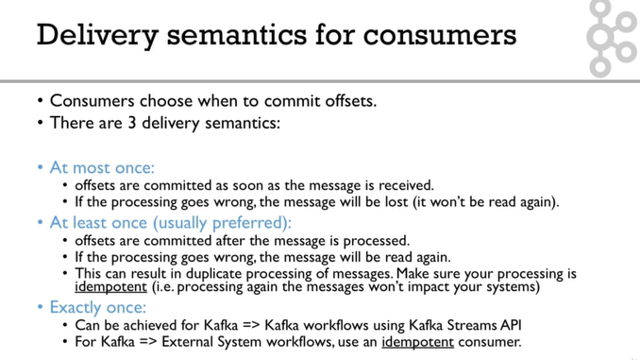

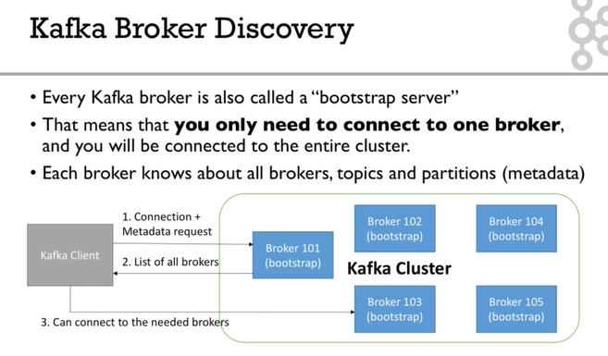

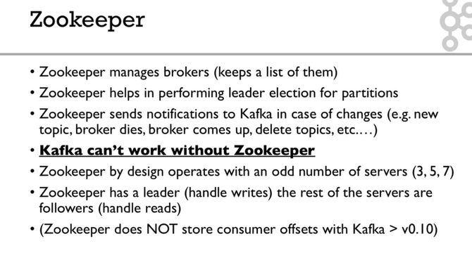

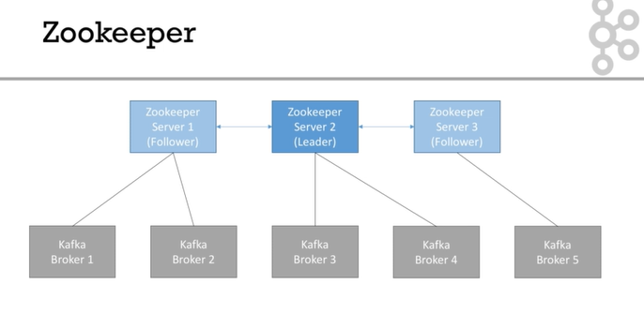

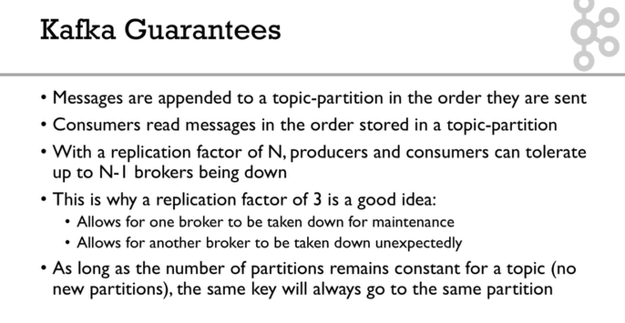

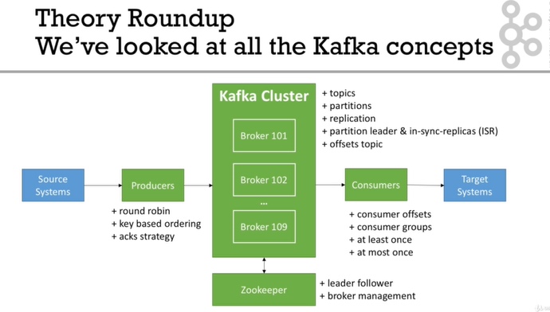

**In summary, for Linux (ex: Ubuntu)**

1. Download and Setup **Java 8 JDK:**
   1. sudo apt install openjdk-8-jdk
2. Download & Extract the Kafka binaries from <https://kafka.apache.org/downloads>
3. Try Kafka commands using bin/kafka-topics.sh (for example)
4. Edit PATH to include Kafka (in ~/.bashrc for example) PATH="$PATH:/your/path/to/your/kafka/bin"
5. Edit Zookeeper & Kafka configs using a text editor
   1. zookeeper.properties: dataDir=/your/path/to/data/zookeeper
   2. server.properties: log.dirs=/your/path/to/data/kafka
6. Start Zookeeper in one terminal window: zookeeper-server-start.sh config/zookeeper.properties
7. Start Kafka in **another** terminal window: kafka-server-start.sh config/server.properties

**Important: For the rest of the course, don't forget to add the extension .sh to commands being run**

Windows - Summary

**In summary, for Windows**

1. Download and Setup **Java 8 JDK**
2. Download the Kafka binaries from <https://kafka.apache.org/downloads>
3. Extract Kafka at the root of C:\
4. Setup Kafka bins in the **Environment variables** section by editing **Path**
5. Try Kafka commands using kafka-topics.bat (for example)
6. Edit Zookeeper & Kafka configs using NotePad++ <https://notepad-plus-plus.org/download/>
   1. zookeeper.properties: dataDir=C:/kafka_2.12-2.0.0/data/zookeeper (yes the slashes are inversed)
   2. server.properties: log.dirs=C:/kafka_2.12-2.0.0/data/kafka (yes the slashes are inversed)
7. Start Zookeeper in one command line: zookeeper-server-start.bat config\zookeeper.properties
8. Start Kafka in **another** command line: kafka-server-start.bat config\server.properties

**Important: For the rest of the course, don't forget to add the extension .bat to commands being run**

**Find all available topics**

C:\project\softwares\kafka_2.12-2.2.0\bin\windows>kafka-topics.bat --zookeeper localhost:2181 --list

__consumer_offsets

test

testjson

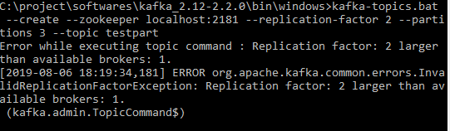

**Describing particular topic**

C:\project\softwares\kafka_2.12-2.2.0\bin\windows>kafka-topics.bat --zookeeper localhost:2181 --topic testpart --describe

Topic:testpart PartitionCount:3 ReplicationFactor:1 Configs:

Topic: testpart Partition: 0 Leader: 0 Replicas: 0 Isr: 0

Topic: testpart Partition: 1 Leader: 0 Replicas: 0 Isr: 0

Topic: testpart Partition: 2 Leader: 0 Replicas: 0 Isr: 0

In the above example partition size is 3 replication factor is 1.

There are 3 partitions as Partition 0, Partition 1, and Partition 2

Leader is Broker 0.

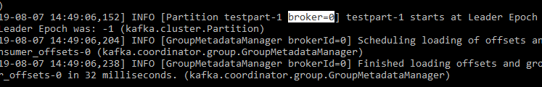

For each partition number of replicas mentioned 0 means the replica is present in broker id 0.

Isr:0 means the in sync replica present in broker 0.

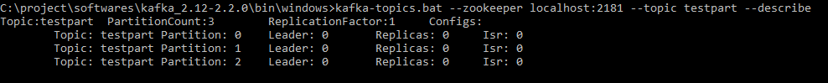

**Commands to start Zookeeper and Kafka**

zookeeper-server-start.bat C:\project\softwares\kafka_2.12-2.2.0\config\zookeeper.properties

kafka-server-start.bat C:\project\softwares\kafka_2.12-2.2.0\config\server.properties

**To see the help of Kafka topic**

C:\project\softwares\kafka_2.12-2.2.0\bin\windows>kafka-topics.bat

**Deleting a topic**

C:\project\softwares\kafka_2.12-2.2.0\bin\windows>kafka-topics.bat --zookeeper localhost:2181 --delete --topic test

Topic test is marked for deletion.

Note: This will have no impact if delete.topic.enable is not set to true.

**Reading Only New Data (Not from Beginning)**

C:\project\softwares\kafka_2.12-2.2.0\bin\windows>kafka-console-consumer.bat --bootstrap-server localhost:9092 --topic test

hiiiii

--bootstrap-server and --broker-list are same it is kafka

**Consumer Group**

All the consumers present in same consumer group will receive the messages from producer based on some algorithm.

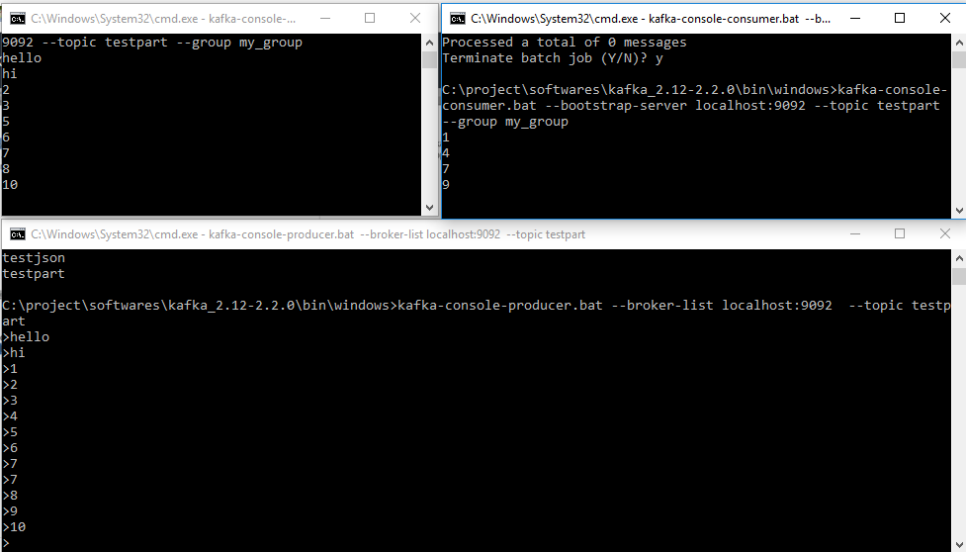

If number of partition is 1 then only one consumer receiving the message.

If number of partitions 3 and we have three consumers then they will read data from different partitions.

If we have 3 partitions and 2 consumers then data from 3 partitions will be read by 2 consumers (available consumers)

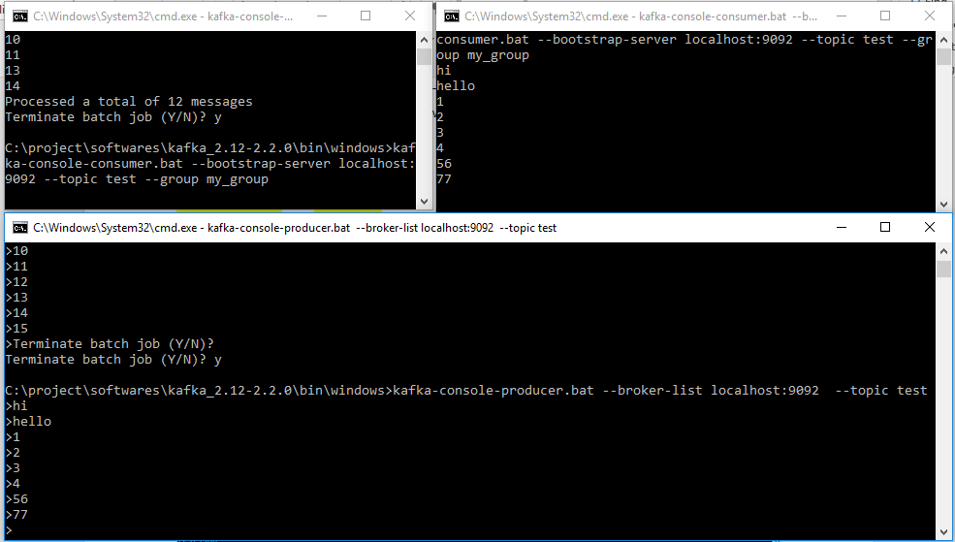

In the consumer if we mention --group and – from-beginning only once it will get all the messages, 2nd time for the same group any other consumer it will not read older messages because the offset has been committed.

**Kafka Consumer Group**

C:\project\softwares\kafka_2.12-2.2.0\bin\windows>kafka-consumer-groups.bat --bootstrap-server localhost:9092 --list

my_group

**Describing a consumer Group**

C:\project\softwares\kafka_2.12-2.2.0\bin\windows>kafka-consumer-groups.bat --bootstrap-server localhost:9092 --group my_group –describe

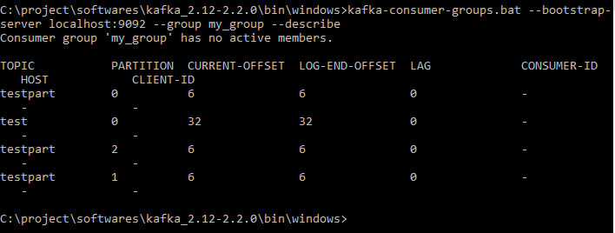

As the lag field is zero there are no pending messages present in topic testpart for consumer group my_group

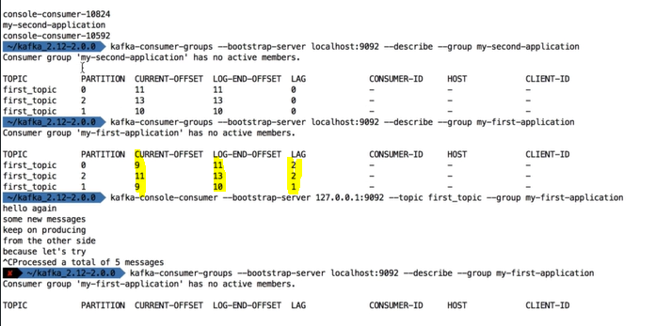

Below image shows which consumer is connected to which partition. In this case one of the consumer accessing 1 partition and another one accessing 2 partitions.

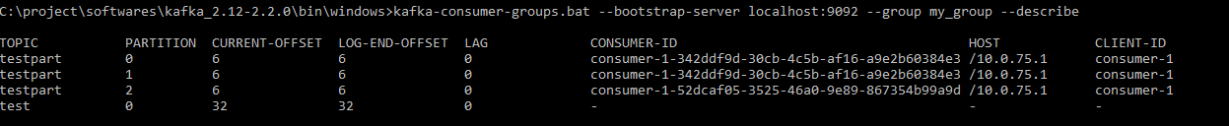

It is possible to reset or shift the current offset the offset

Producer with keys

1. kafka-console-producer --broker-list 127.0.0.1:9092 --topic first_topic --property parse.key=true --property key.separator=,
2. > key,value
3. > another key,another value

Consumer with keys

1. kafka-console-consumer --bootstrap-server 127.0.0.1:9092 --topic first_topic --from-beginning --property print.key=true --property key.separator=,

**What about UIs?**

Kafka does not come bundled with a UI, but here are some recommendations

Kafka Manager (for managing Kafka and instead of using CLI): https://github.com/yahoo/kafka-manager

Kafka Tools (will be explore in the next lecture)

You may find other UIs on the internet

Overall in this course, we perform all the actions without any UI, which is good for learning how to properly use the CLI

//kafkaJsonTemplate.send(topic, key, data);

//providing a key ensures that a particular key always go to 1 specific partition

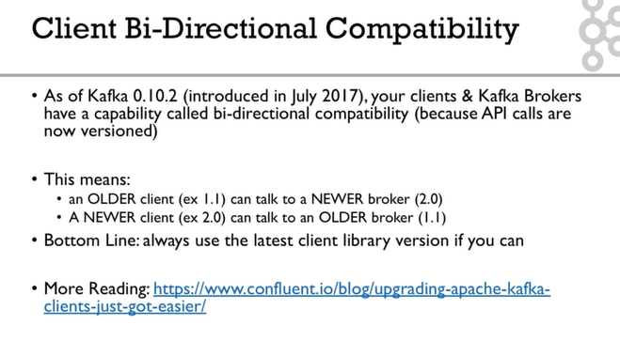

**Real World Exercise**

Before jumping to the next section for the solution, here are some pointers for some exercises:

**Twitter Producer**

The Twitter Producer gets data from Twitter based on some keywords and put them in a Kafka topic of your choice

Twitter Java Client: https://github.com/twitter/hbc

Twitter API Credentials: https://developer.twitter.com/

**ElasticSearch Consumer**

The ElasticSearch Consumer gets data from your twitter topic and inserts it into ElasticSearch

ElasticSearch Java Client: https://www.elastic.co/guide/en/elasticsearch/client/java-rest/6.4/java-rest-high.html

ElasticSearch setup:

https://www.elastic.co/guide/en/elasticsearch/reference/current/setup.html

OR <https://bonsai.io/>

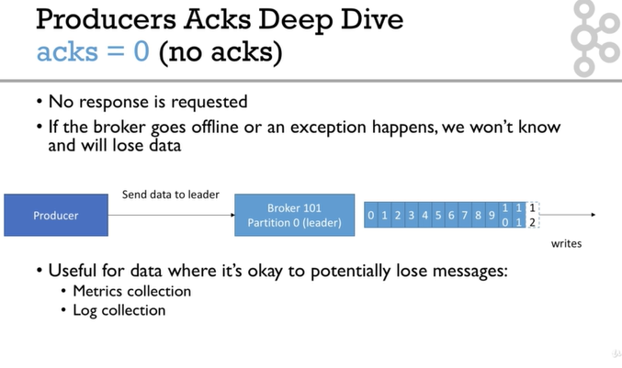

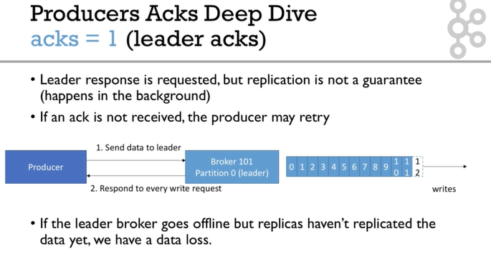

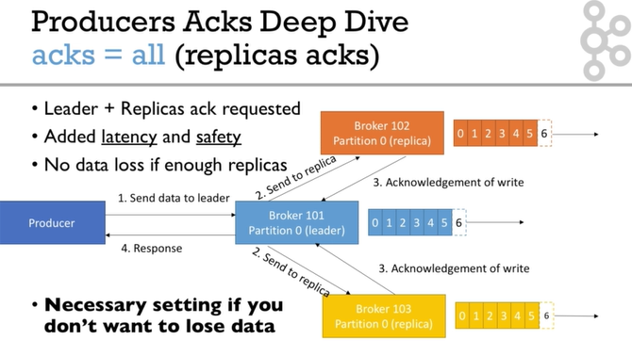

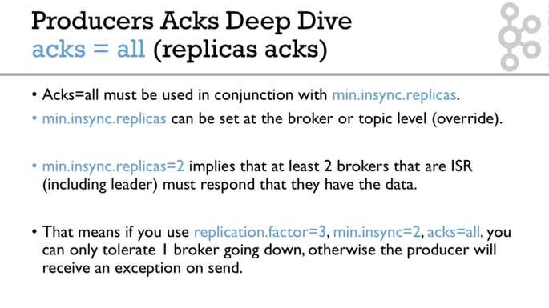

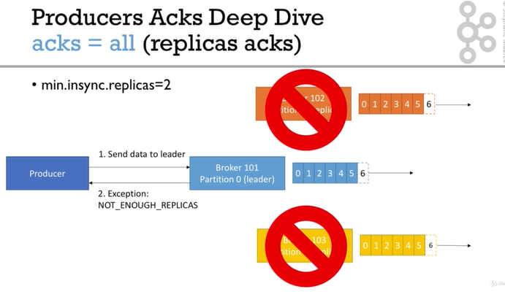

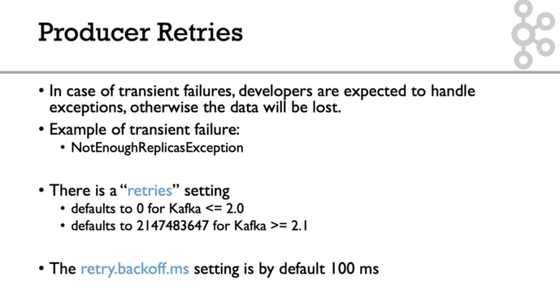

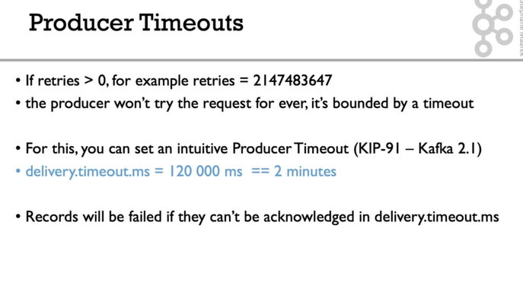

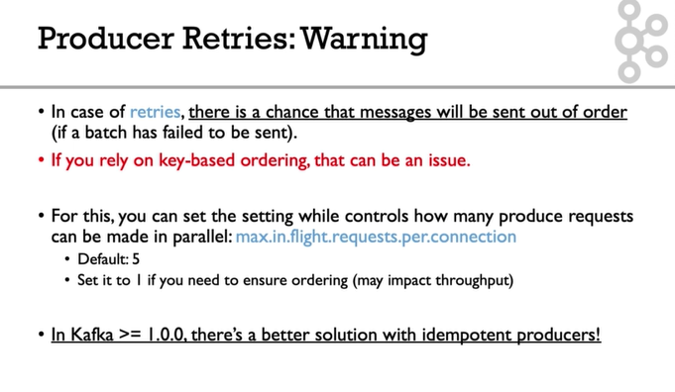

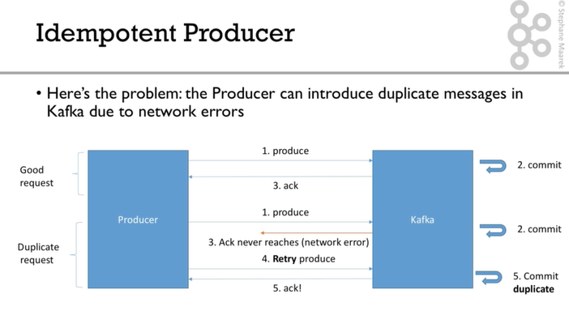

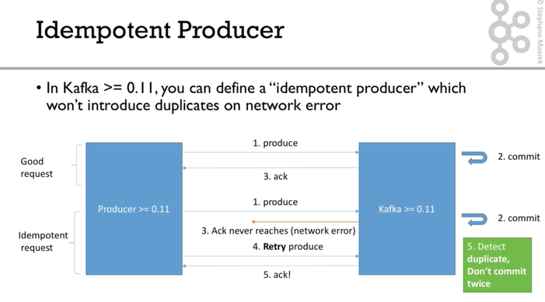

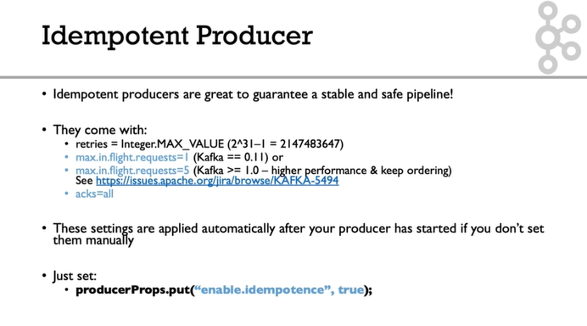

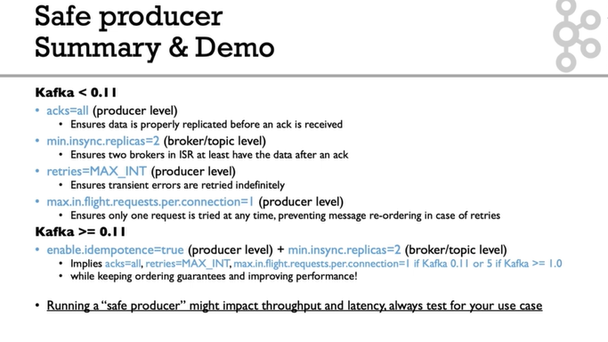

**Important configurations**

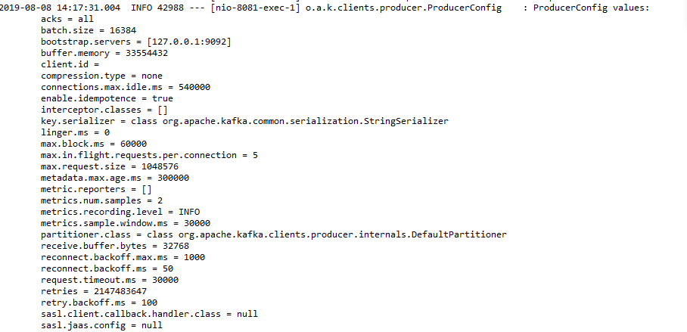

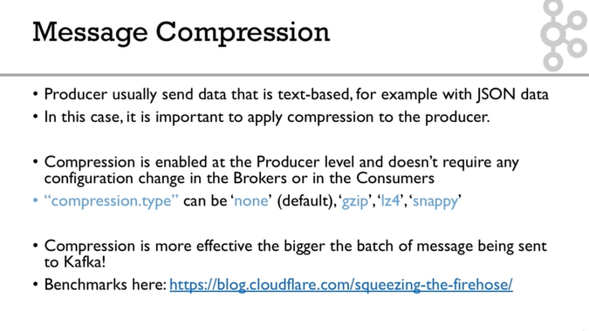

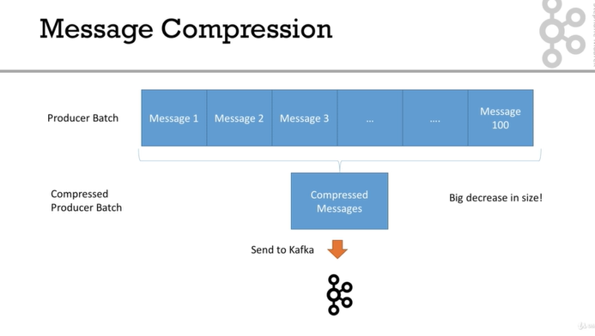

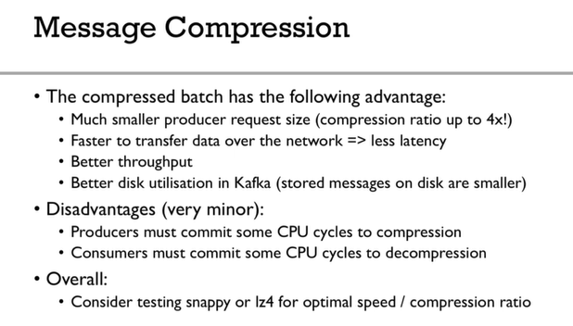

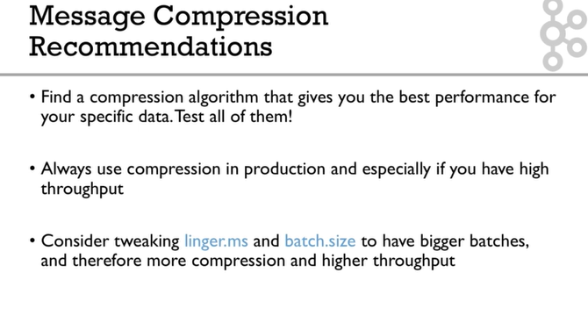

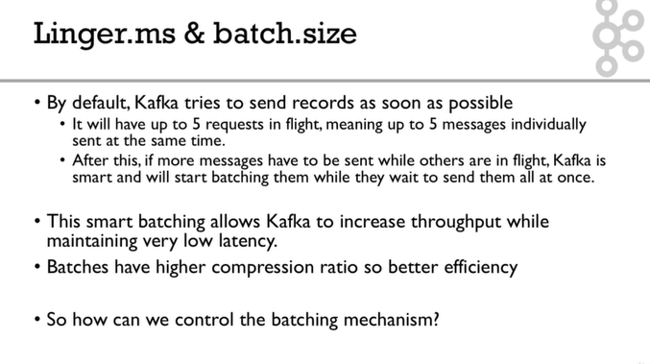

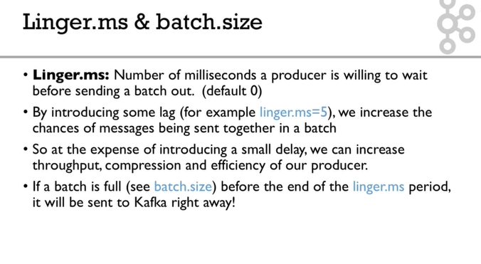

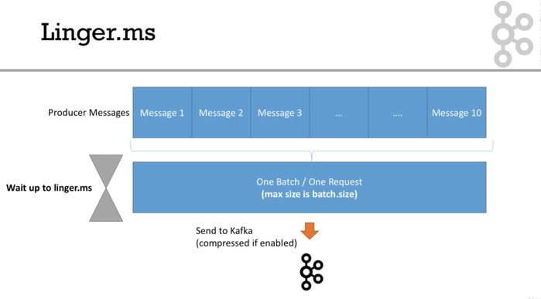

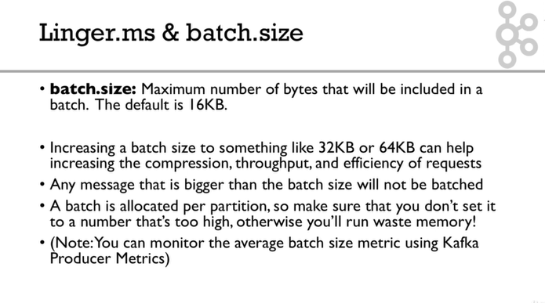

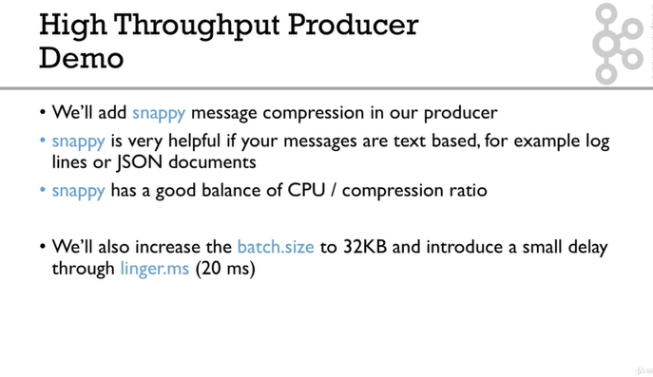

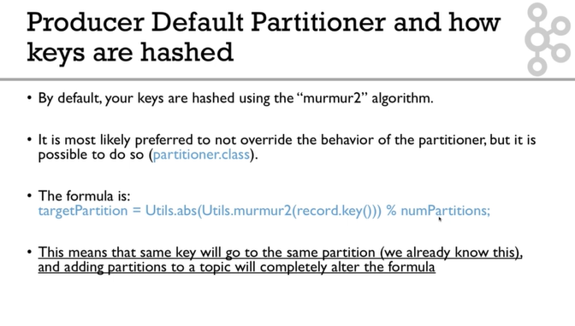

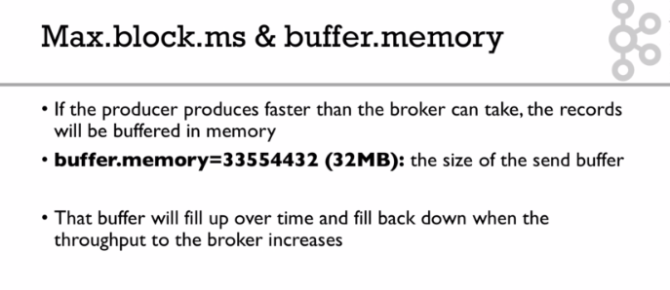

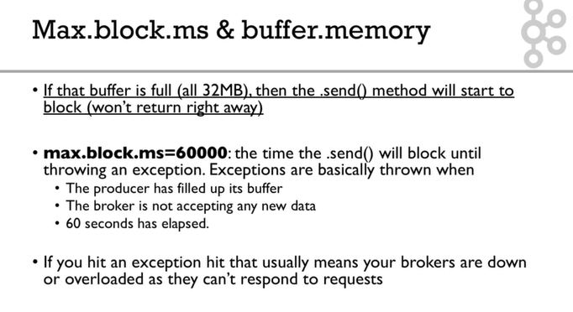

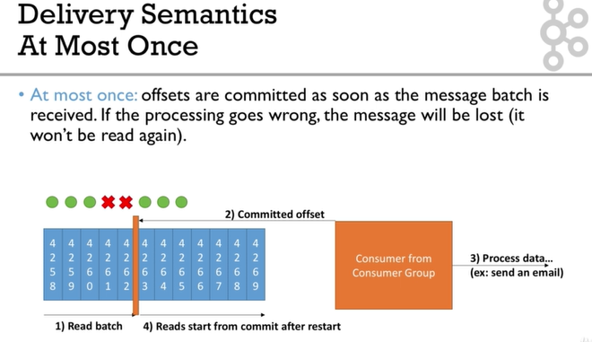

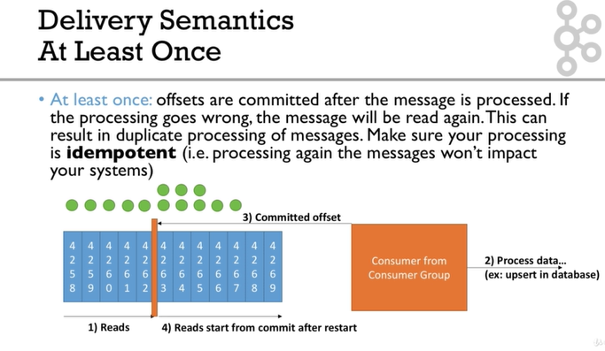

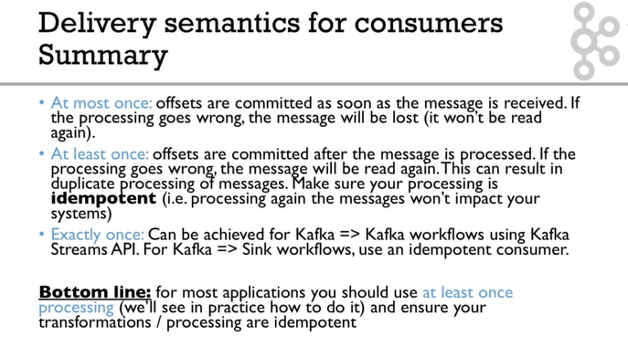

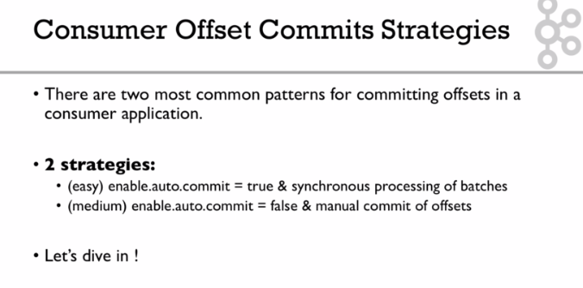

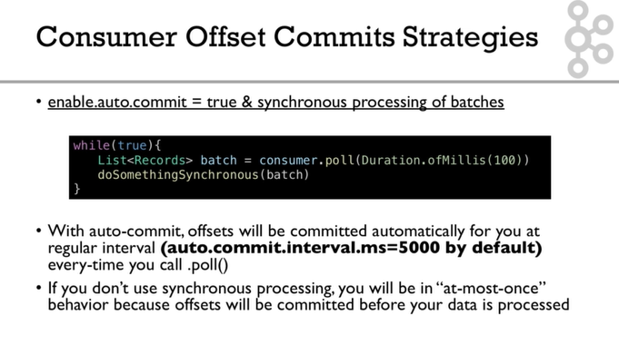

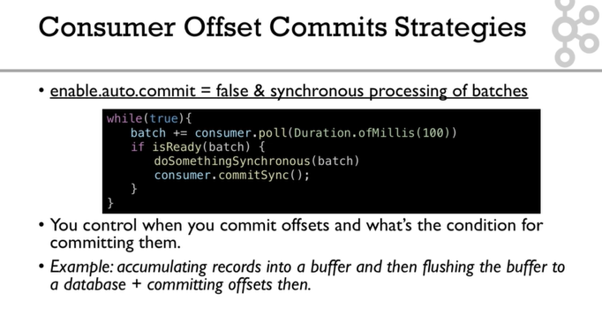

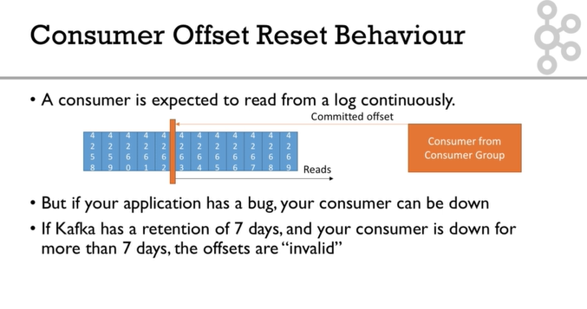

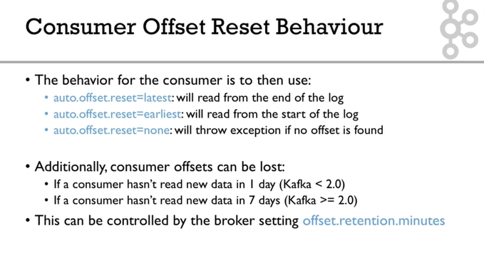

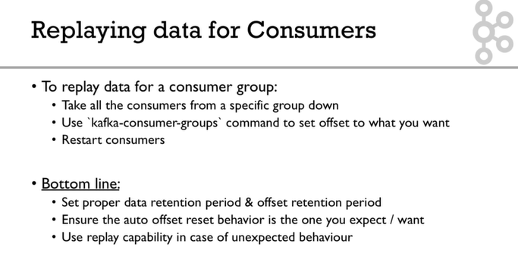

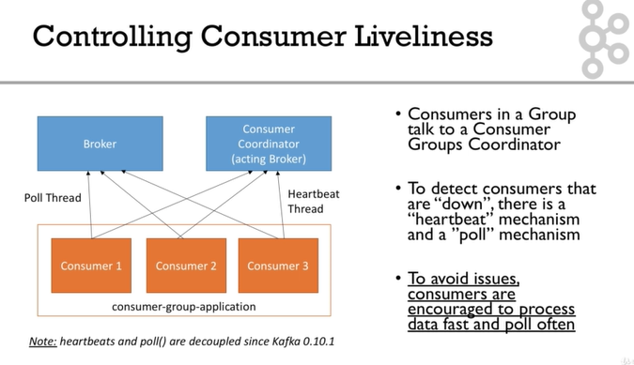

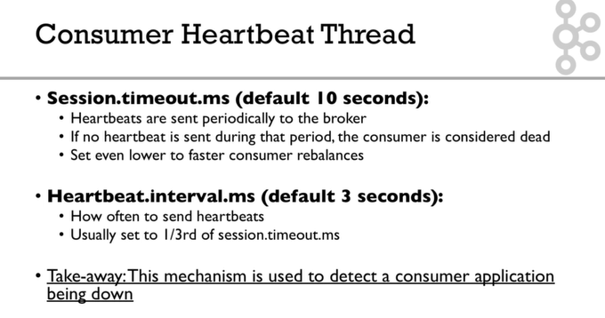

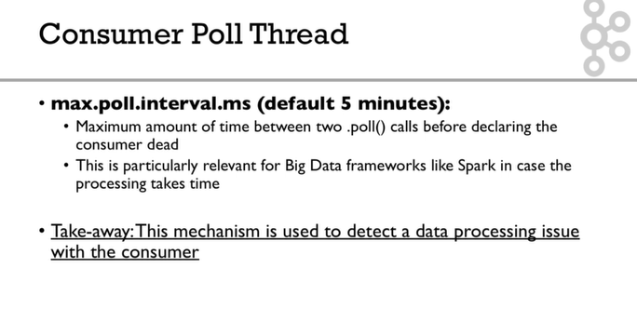

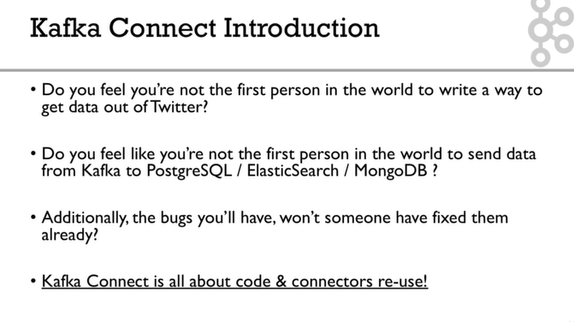

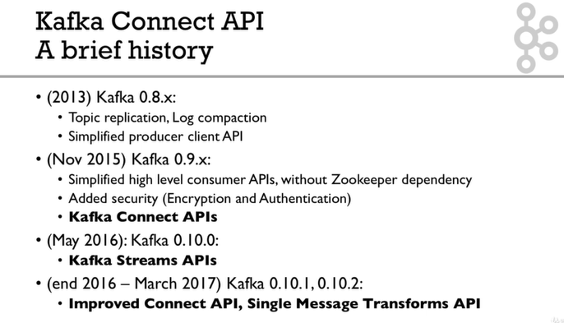

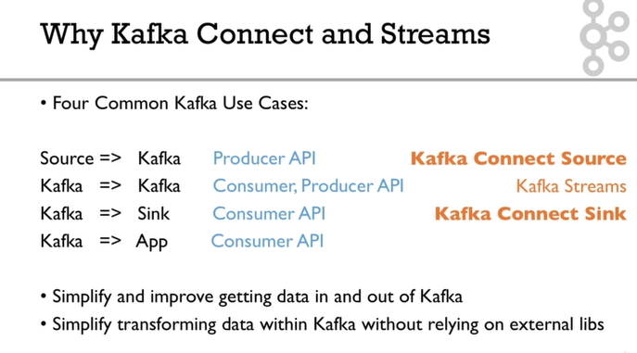

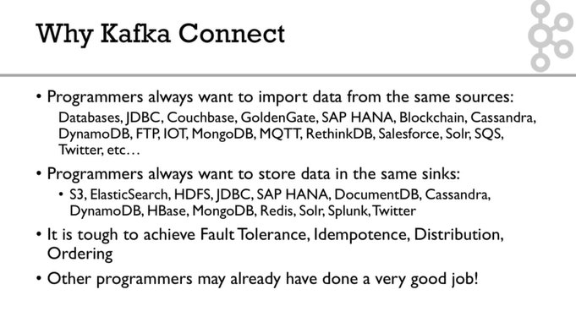

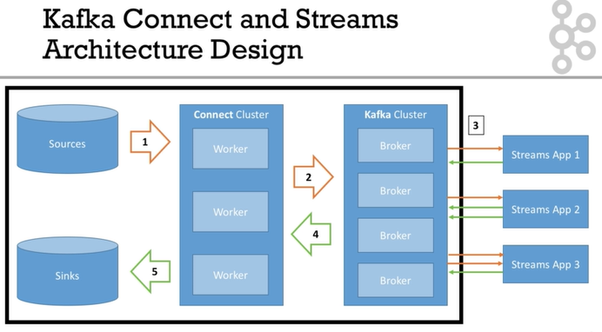

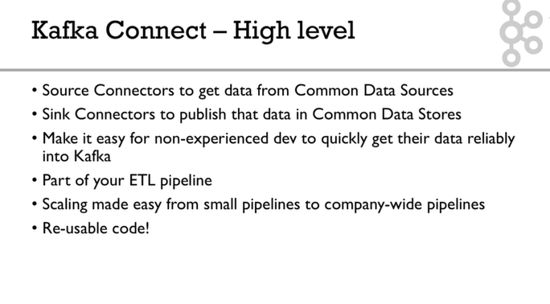

Note on Docker Setup

#### ****Note on Docker Setup****

Docker is notoriously hard to setup on some machines, and can have obscure bugs. If you don't know Docker at all, I recommend you first learn a bit about it online.

Running Kafka on Docker is even harder, and requires some deep understanding of Docker and Kafka.

Thankfully, I have created a project to make things easy for beginners: <https://github.com/simplesteph/kafka-stack-docker-compose>

#### ****Installing Docker:****

See here: <https://store.docker.com/search?type=edition&offering=community>

Note to Windows users: Docker is really hard to setup on your machines, may require Windows 10, might require disabling Hyper-V, and tinkering VirtualBox. If you cannot setup Docker, the best help you will get will be on Google.

**Overall for all Windows users but Windows 10, I recommend not to run Kafka in Docker, and use the binaries instead**

**https://kafka-niranjan-test.com**

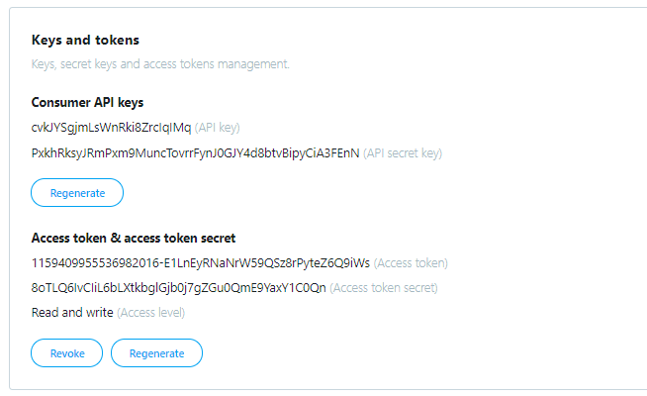

### Keys and tokens

Keys, secret keys and access tokens management.

##### Consumer API keys

cvkJYSgjmLsWnRki8ZrcIqIMq (API key)

PxkhRksyJRmPxm9MuncTovrrFynJ0GJY4d8btvBipyCiA3FEnN (API secret key)

Regenerate

##### Access token & access token secret

1159409955536982016-E1LnEyRNaNrW59QSz8rPyteZ6Q9iWs (Access token)

8oTLQ6IvCIiL6bLXtkbglGjb0j7gZGu0QmE9YaxY1C0Qn (Access token secret)

Read and write (Access level)

RevokeRegenerate